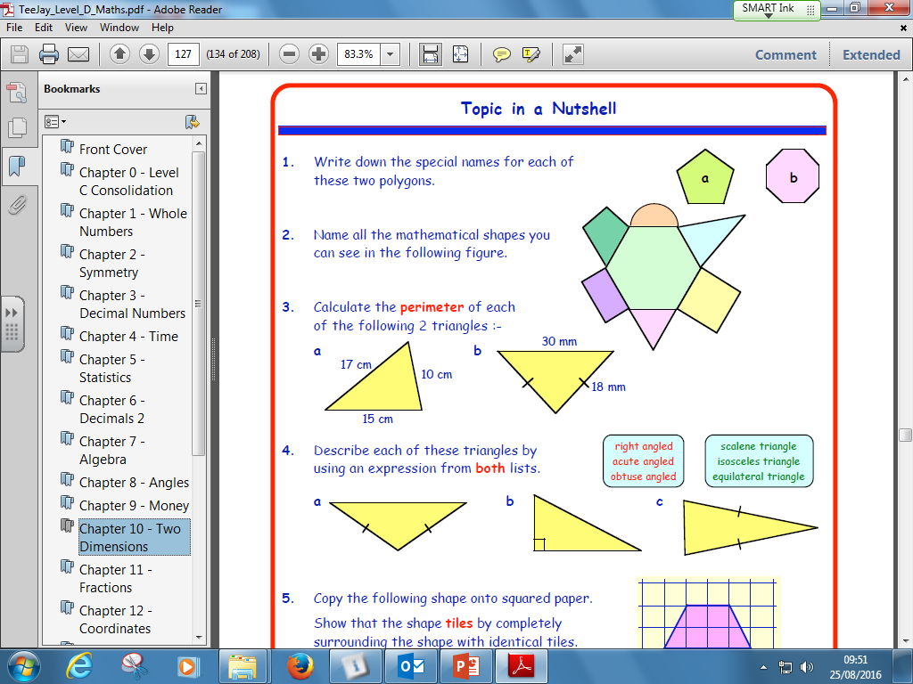S2 Homework

1. Calculate, showing working.

a) 27 – 5 x 3 b) 22.2 ÷ (3.1 + 8) c) (9 – 3 x 2)2  ÷( 18 ÷ 6)

d) 92 + 42 + (4 - 2)2 - 1 e) 1050 – (12 –2)3

6. Write 12 as a product of prime factors

7. Simplify:

1. b x b b) 4 x f x g c) c x c x d d) a + a + a + a

e) 5x + 3y – 2x – y f) xy + 2y + 3xy + 4y